

Installation Guide

EGCS Starter Portal



Introduction

This installation provides the step-by-step instructions to install the EGCS Starter Portal to a Dataverse environment. With the emergence of Protected B cloud in the Government of Canada, your department now has access to SaaS and PaaS solutions such as PowerApps, Dynamics 365 SaaS, Azure B2C and Azure DevOps with advanced reporting and monitoring services to provide you with a secure, performant, and reliable service that is maintained by Microsoft M365 and Azure thereby abstracting the complexities of hosting on premise custom portal and back-office CRM solution and spreadsheets. Hence, leveraging the EGCS Starter Portal as an accelerator to administer Grants & Contributions in your Department’s Cloud subscription together with an external facing portal that is configured with WET, you are empowered to provide modern services to both internal staff and external users applying for G&C.

Table of Contents

Introduction 2

Configuring your Environment 4

PRE-REQUISITES 4

STEP 1: NAVIGATE TO THE POWERPLATFORM ADMIN CONSOLE AND CREATE A NEW ENVIRONMENT 4

STEP 2: GO TO THE POWERAPPS ADMIN CONSOLE AND CREATE A PORTAL FOR YOUR NEW ENVIRONMENT 5

STEP 3: REMOVE FILE RESTRICTIONS FROM DATAVERSE (CRM) 6

Open the Advanced Settings in the same Environment 7

In the site map, expand Settings, select Administration and System Settings and Navigate to the General tab 7

STEP 4: IMPORT THE CRM SOLUTION 9

Expand Settings and go to Solutions 9

Press the Import Solution Button and ***Import the EGCSModelDS*** Solution 9

Press the Import Solution Button and ***Import the EGCS Portal Accelerator/PT*** Solution 10

STEP 5: IMPORT THE PORTAL 11

Download the CRM SDK 11

Open the Configuration Migration Utility 11

Select the EGCS-Starter-Portal-v1 zip file and press import 14

Go the PowerApps admin console to update the binding and restart the portal 14

Select the EGCS Portal Accelerator under the Website Binding dropdown (if not already selected) 15

Restart the portal and Test the Installation 16

Validate that the CRM Model Driven App has been Successfully Installed 17

Configuring your Environment

## PRE-REQUISITES

You must perform the steps in this section as an Azure Global Administrator, OR a user with the following azure roles: Dynamics 365 Administrator, PowerPlatform Administrators, Application Administrator.

## STEP 1: NAVIGATE TO THE POWERPLATFORM ADMIN CONSOLE AND CREATE A NEW ENVIRONMENT

<https://admin.powerplatform.microsoft.com/>

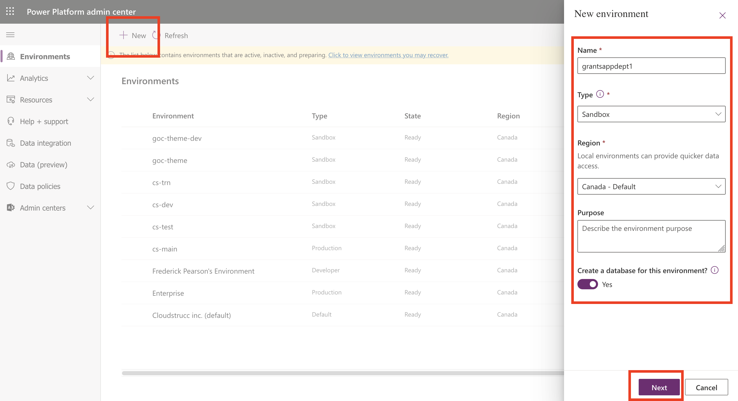

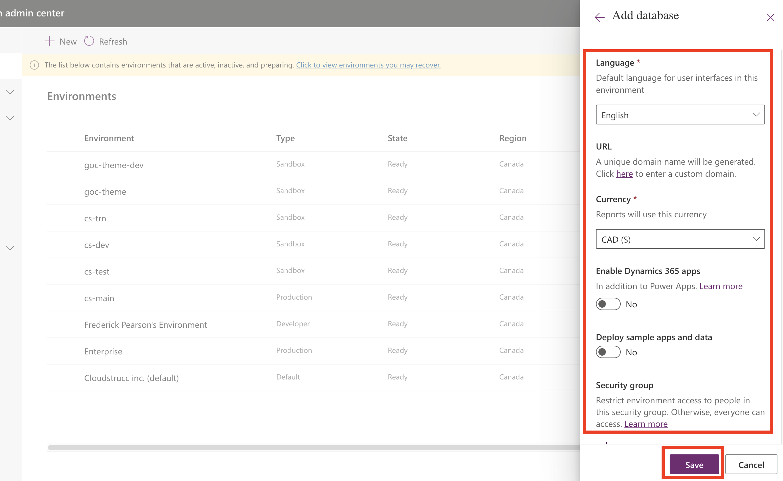

Once saved, the environment will take several minutes to provisioned. Once provisioned, proceed to step 2

## STEP 2: GO TO THE POWERAPPS ADMIN CONSOLE AND CREATE A PORTAL FOR YOUR NEW ENVIRONMENT

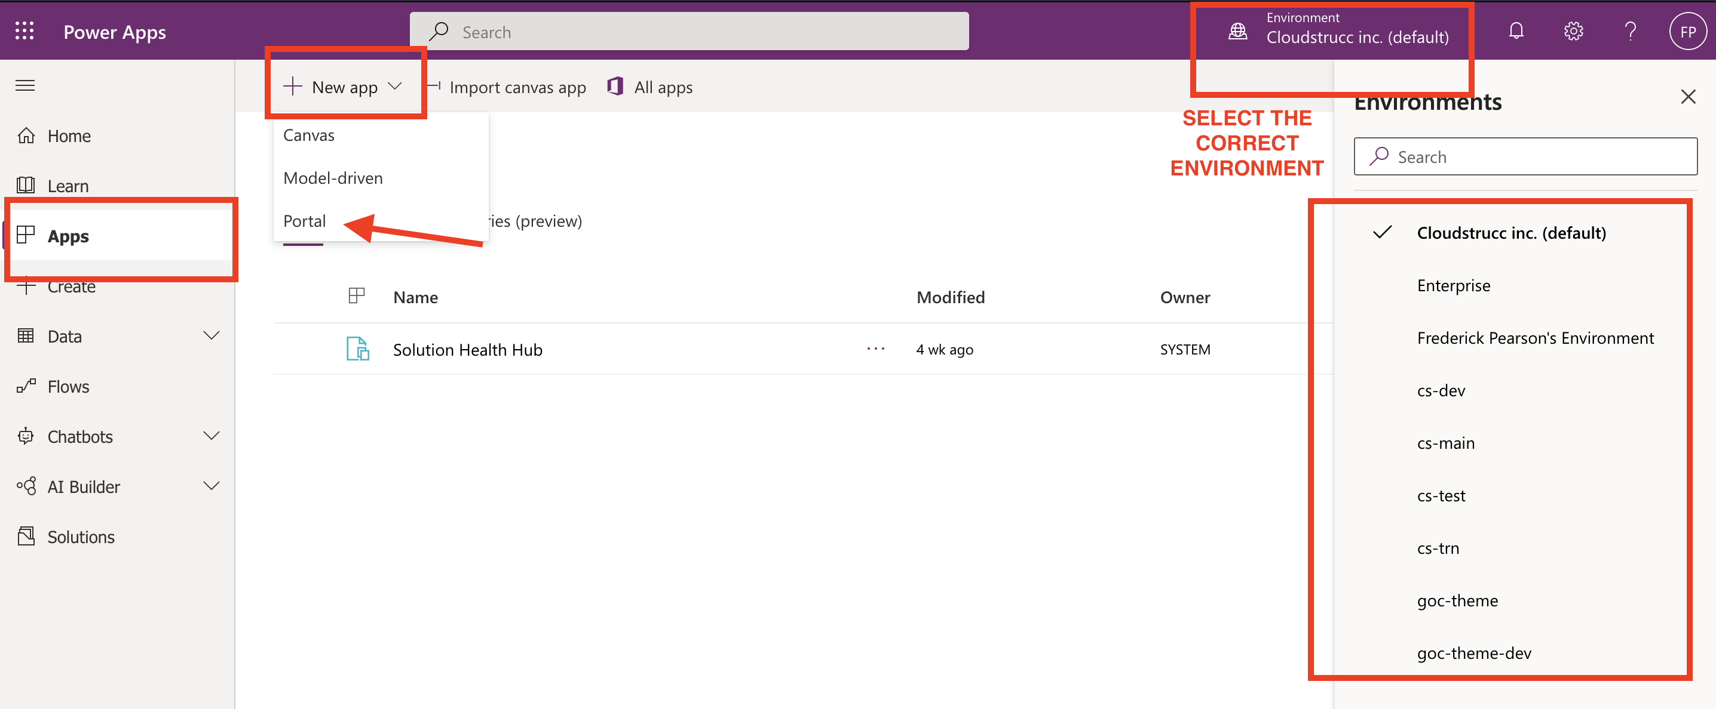

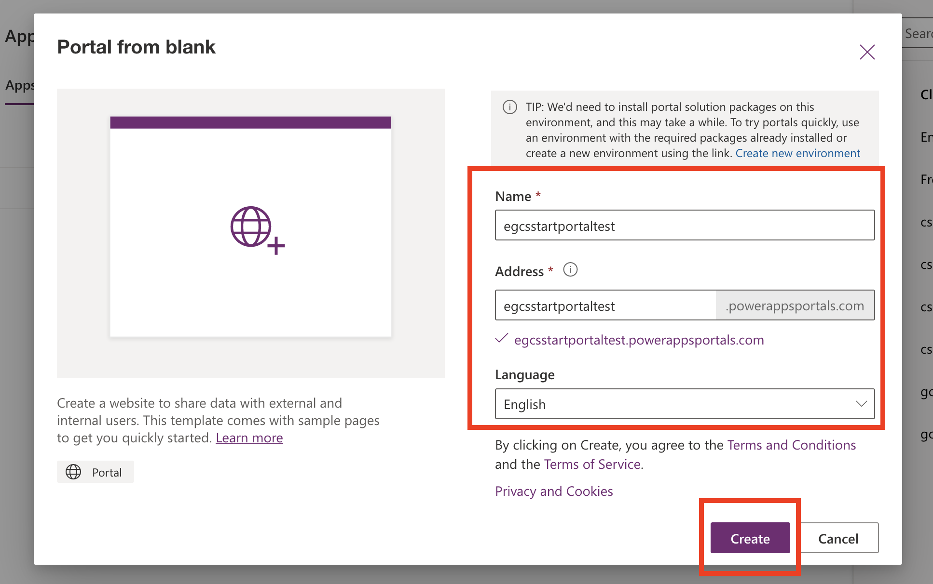

Once created, the provisioning may take several minutes. Once fully provisioned, proceed to Step 3.

## STEP 3: REMOVE FILE RESTRICTIONS FROM DATAVERSE (CRM)

The portal import includes files such as JS, CSS and other file types that are not allowed when importing into the Dataverse. This feature also has file size limits which also need to be updated to allow the portal file imports to work. Once the import is completed, the restrictions should be re-added.

### Open the Advanced Settings in the same Environment

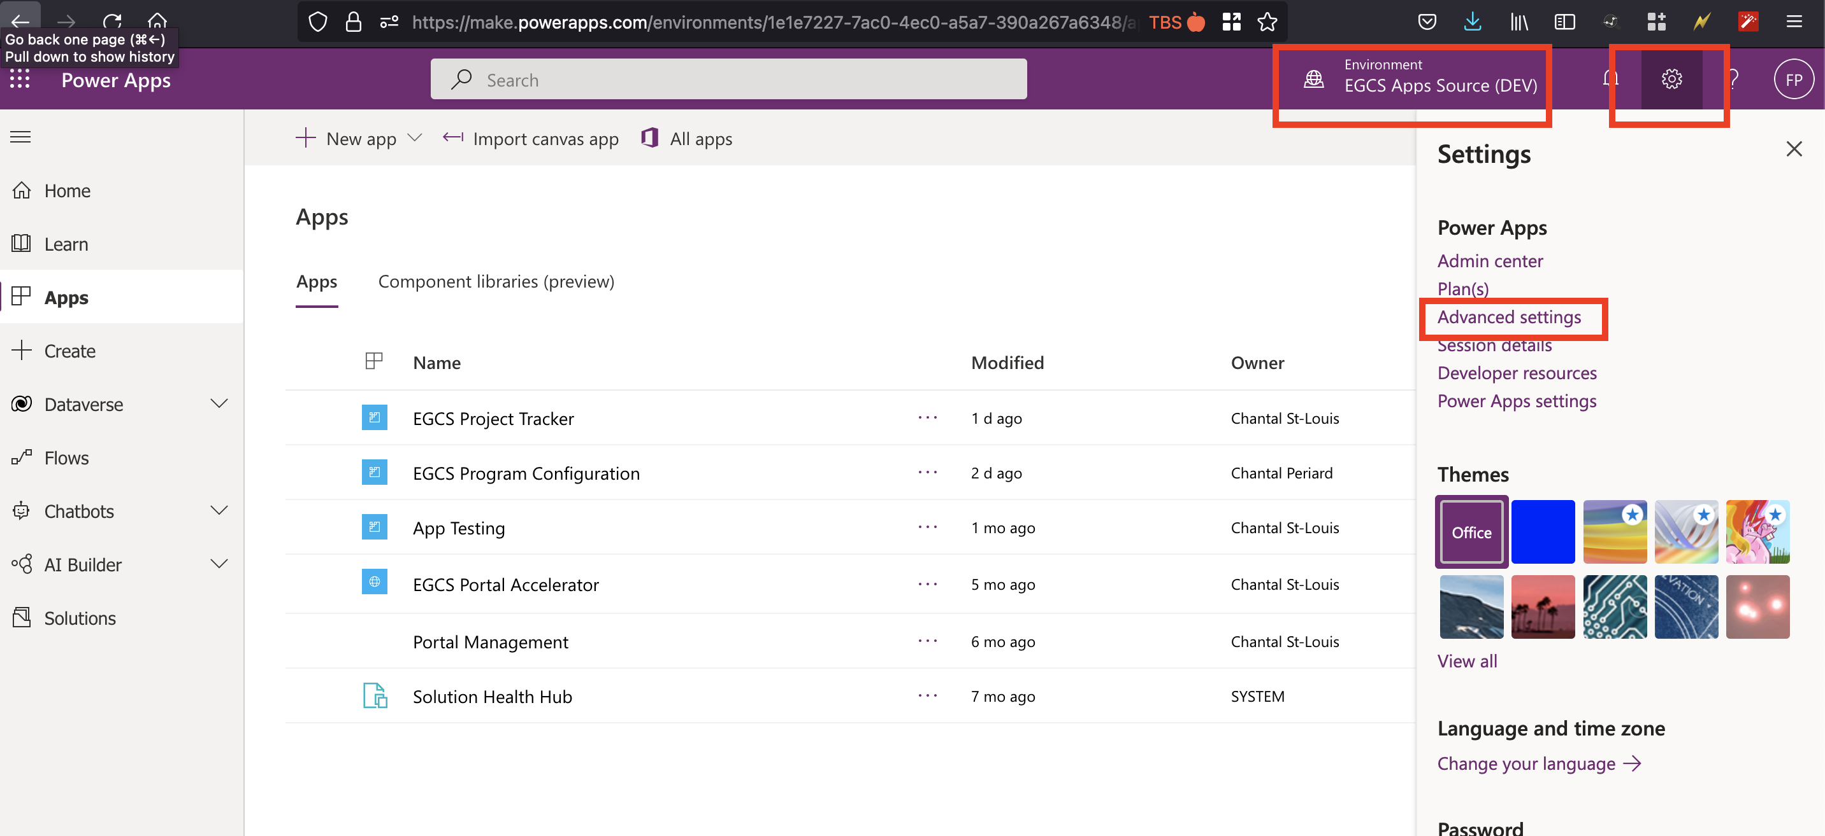

### In the site map, expand Settings, select Administration and System Settings and Navigate to the General tab

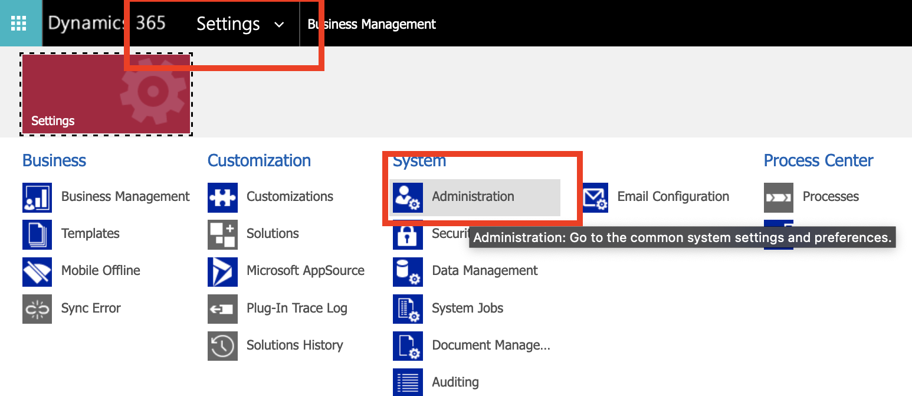

Scroll down and “cut” all the file extension restrictions (paste it somewhere else to re-add these post import).

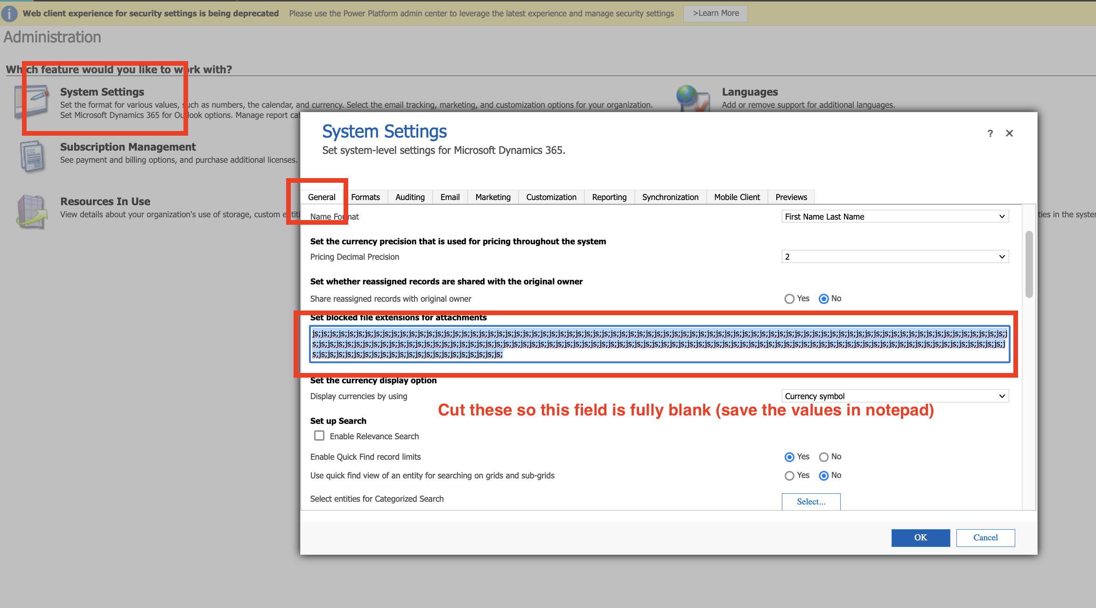

In the email tab raise the File Size (kb) to 100000 (remember the original value and re set it to the original post import).

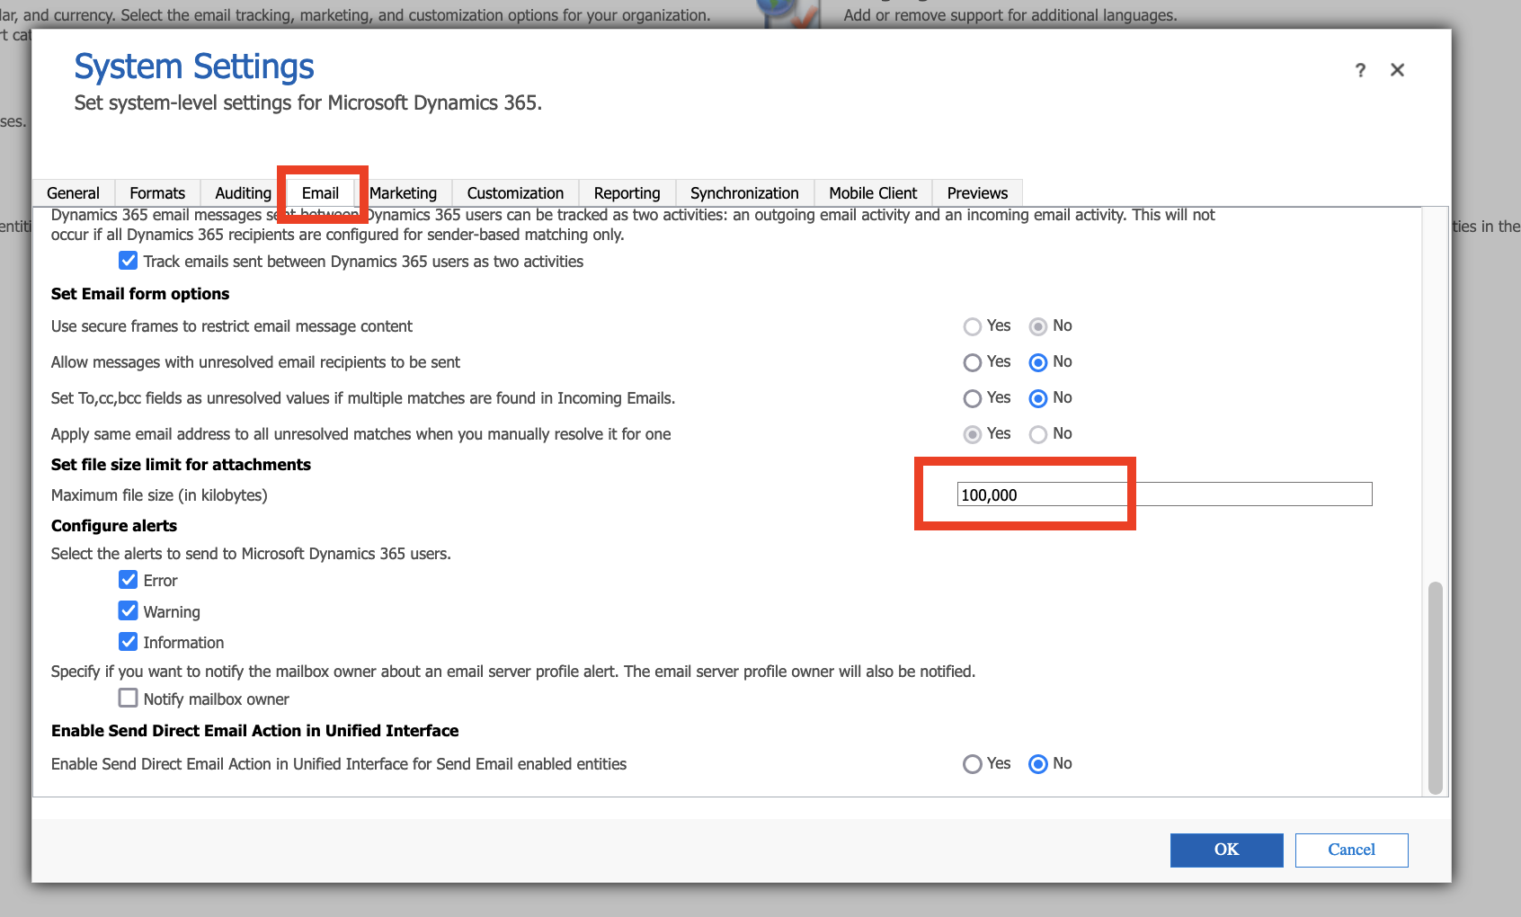

## STEP 4: IMPORT THE CRM SOLUTION

### Expand Settings and go to Solutions

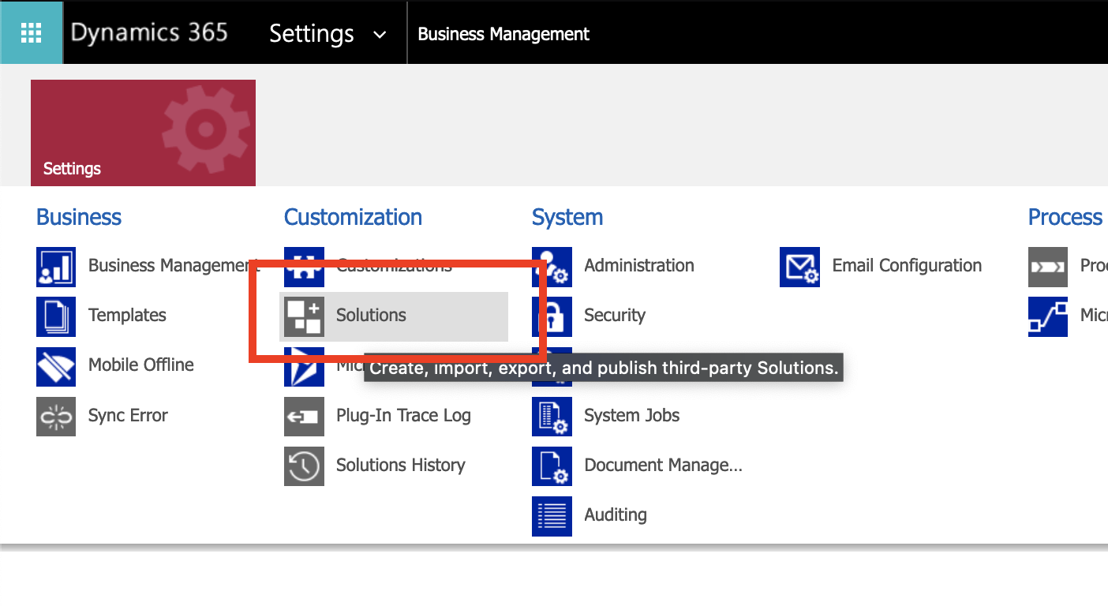

### Press the Import Solution Button and ***Import the EGCSModelDS*** Solution

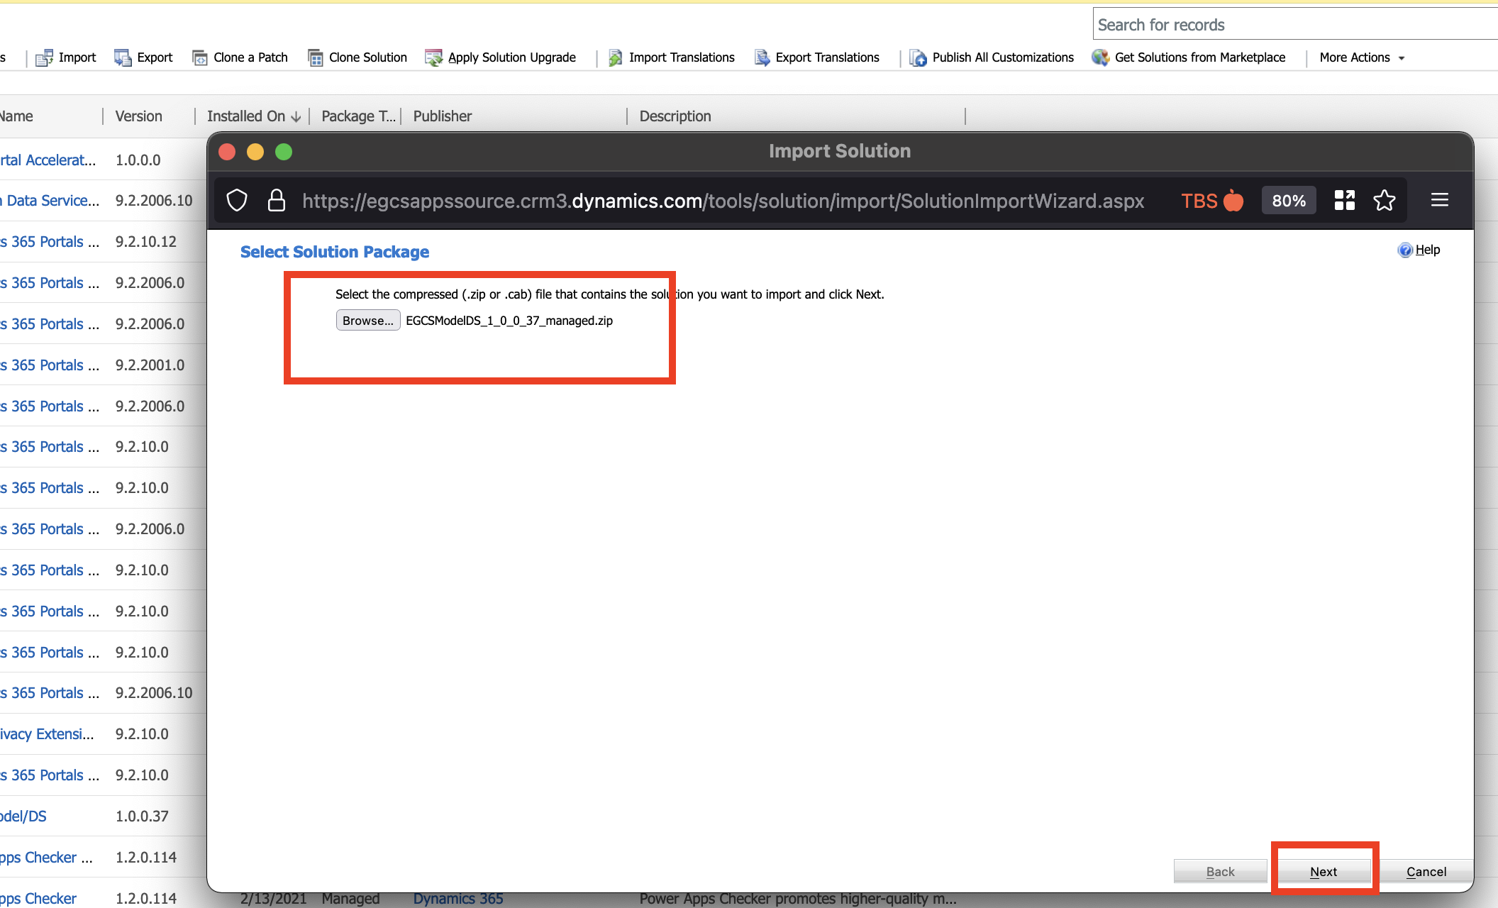

Once completed proceed to the next step.

### Press the Import Solution Button and ***Import the EGCS Portal Accelerator/PT*** Solution

Choose the unmanaged or managed version of the solution. In this example we are using the managed version.

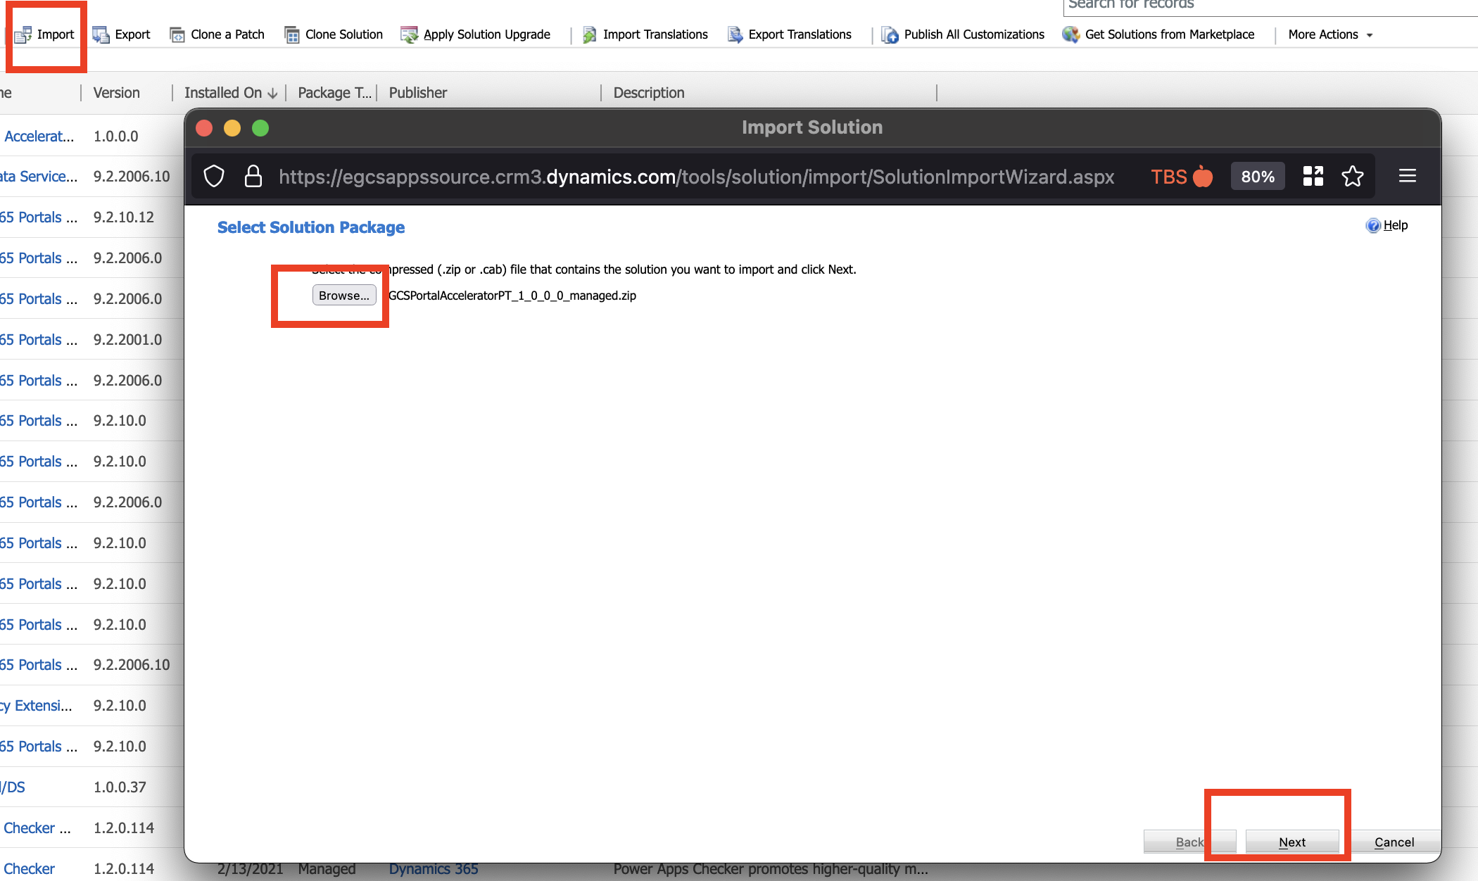

Press “Publish All Customizations” if you’ve imported the unmanaged version.

## STEP 5: IMPORT THE PORTAL

Download the CRM SDK

URL: <https://xrm.tools/SDK> or install using the official Microsoft Documentation here (requires PowerShell): <https://docs.microsoft.com/en-us/dynamics365/customerengagement/on-premises/developer/download-tools-nuget?view=op-9-1>

### Open the Configuration Migration Utility

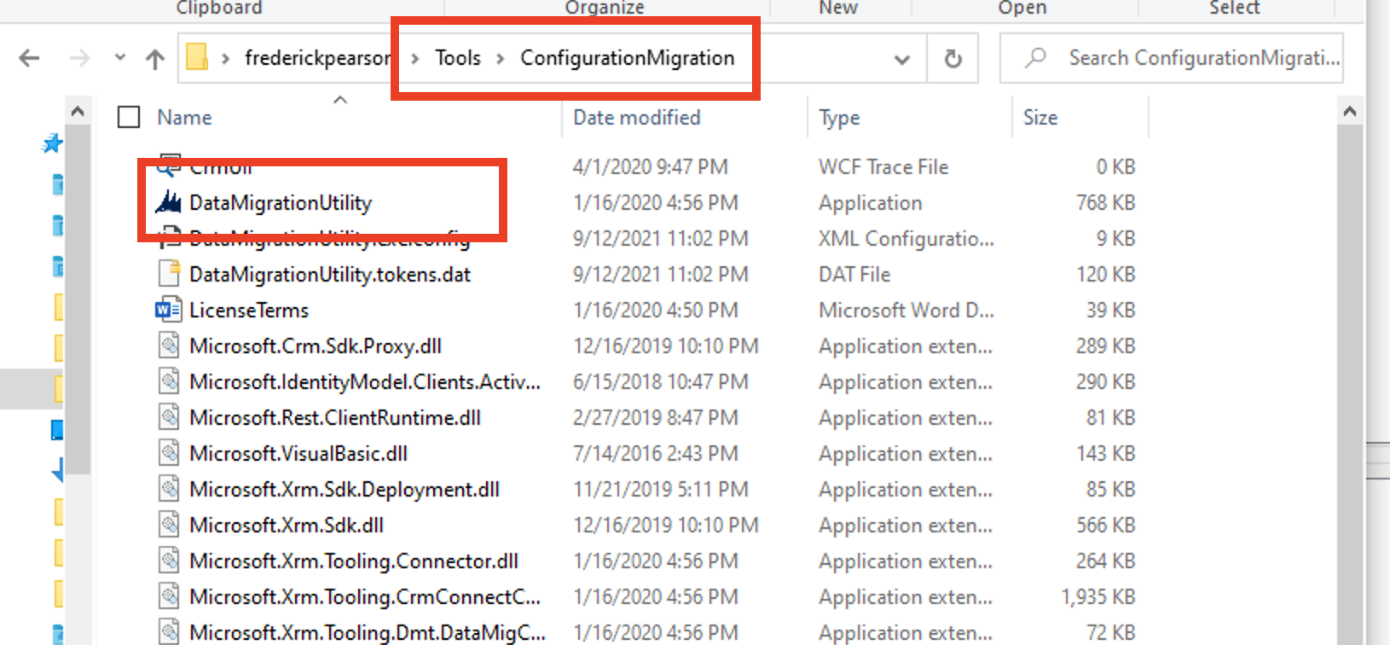

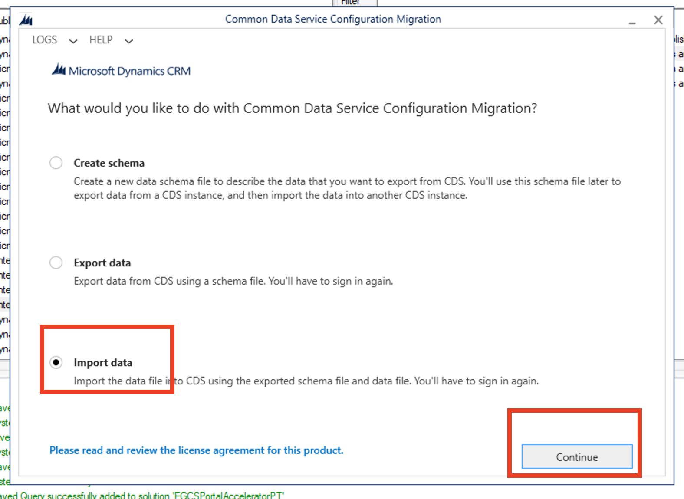

Sign in to your M365 environment with a user account who is a System Administrator (regular user or Application User) OR the user who provisioned the environment (who is automatically a system administrator once the Dataverse is provisioned).

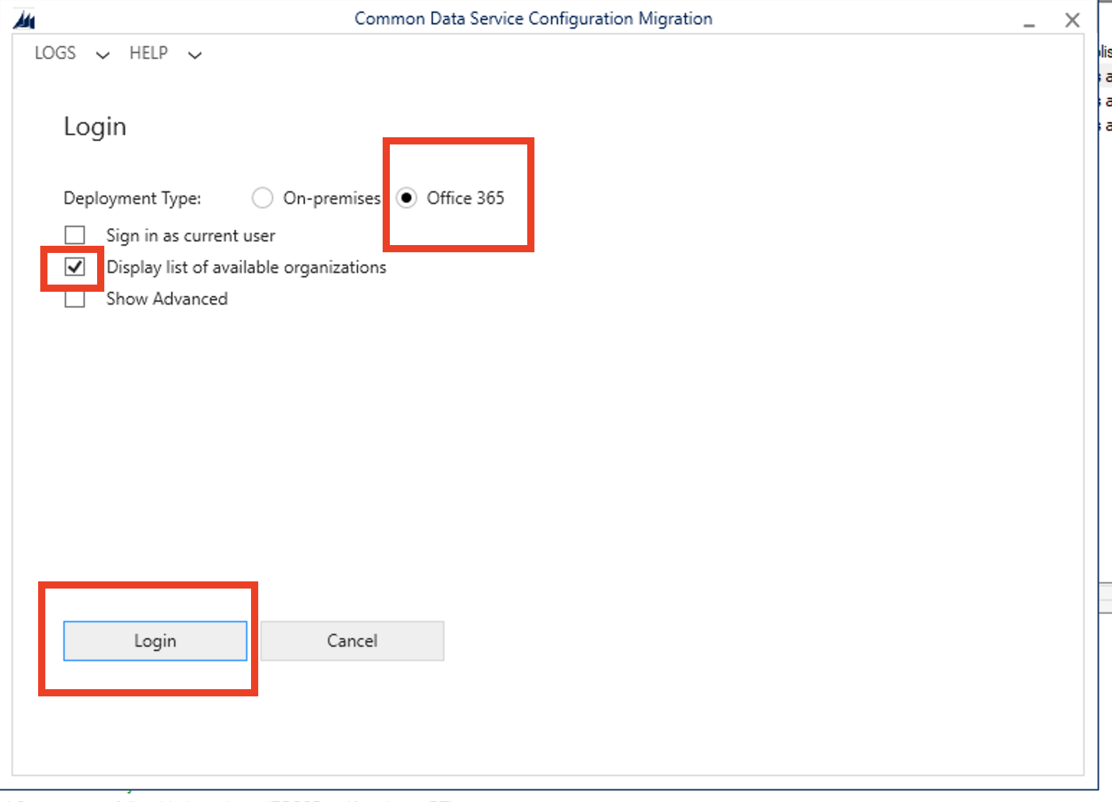

**Select the correct environment and press Login**

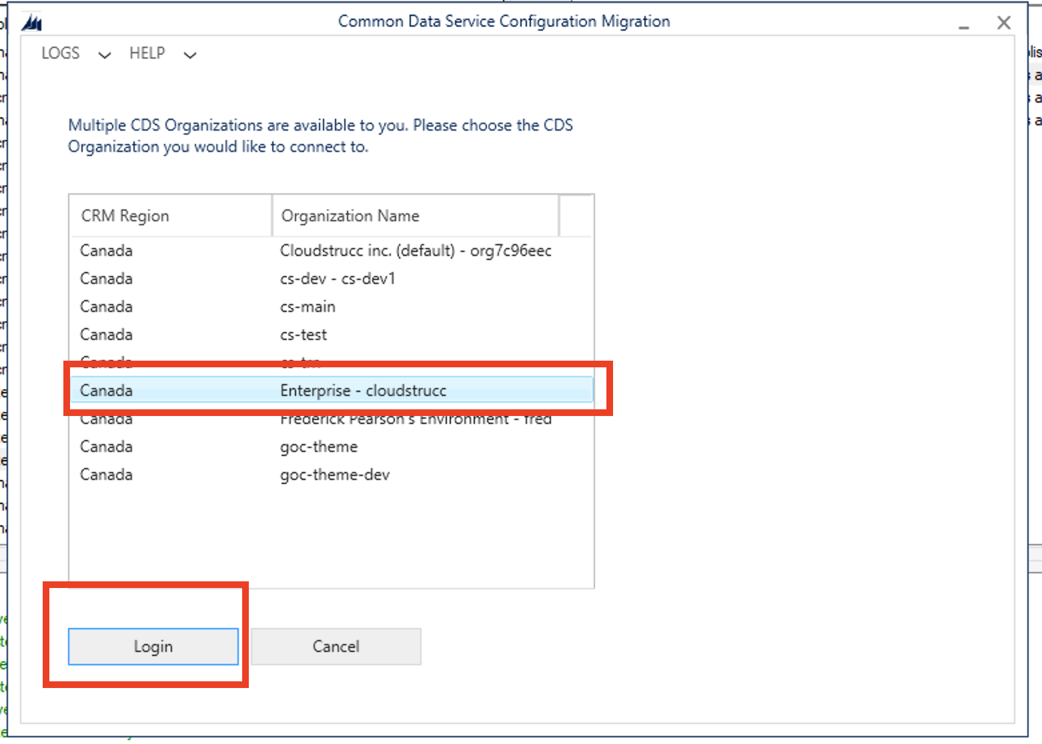

### Select the EGCS-Starter-Portal-v1 zip file and press import

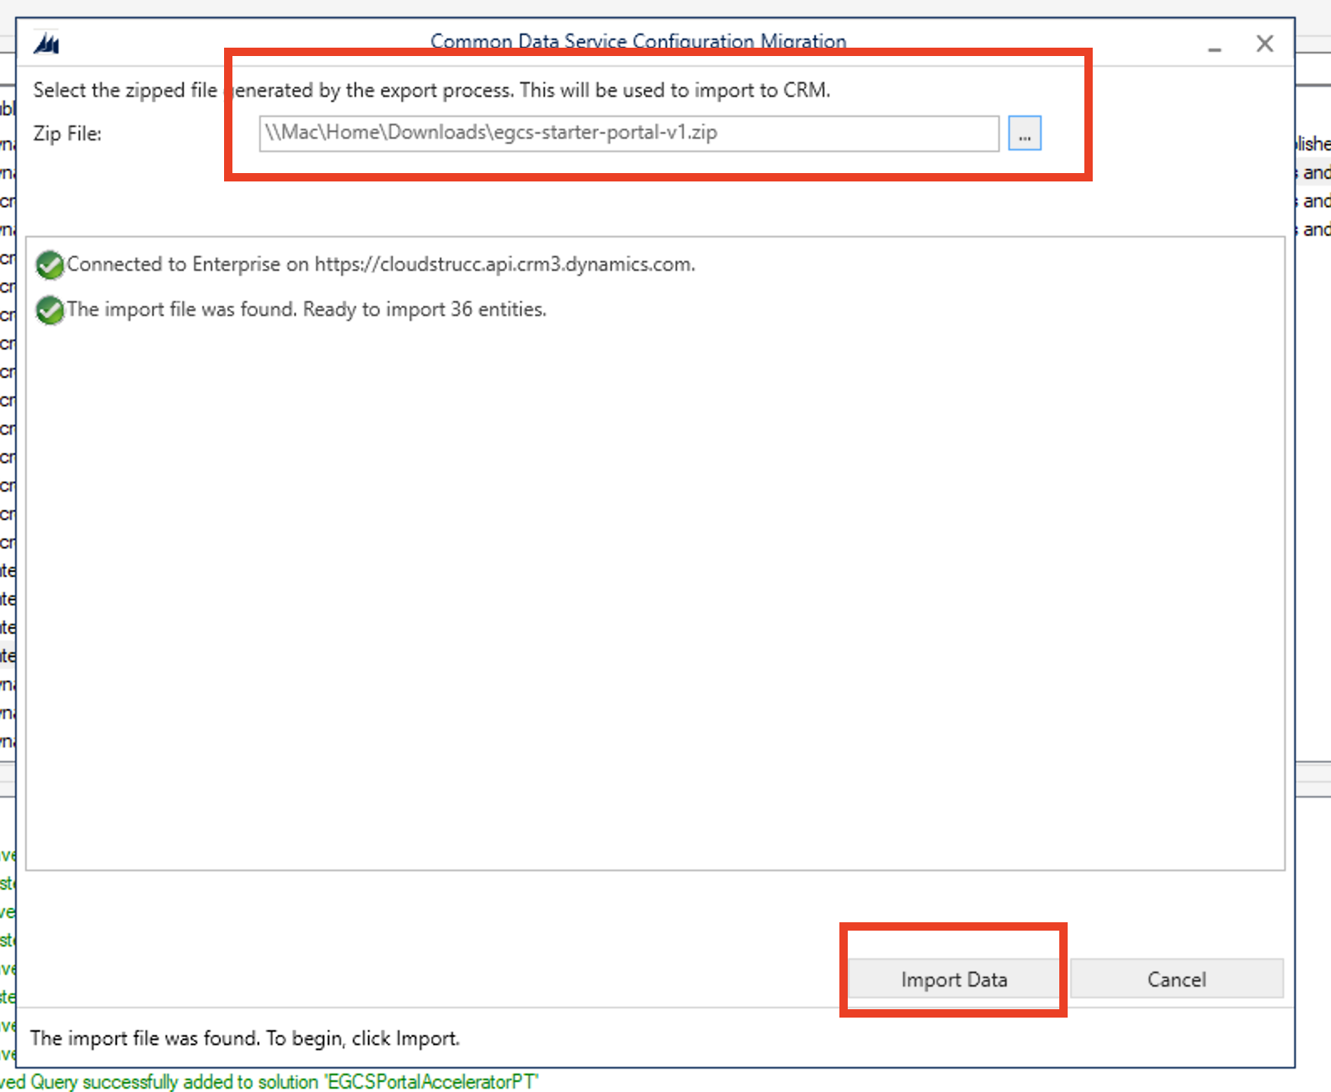

**This will take a while. Once completed follow the next step.**

### Go the PowerApps admin console to update the binding and restart the portal

<https://make.powerapps.com>

Select your environment, click on Apps on the left menu, select the Portal App that you provisioned then press the ellipsis and select “Settings”

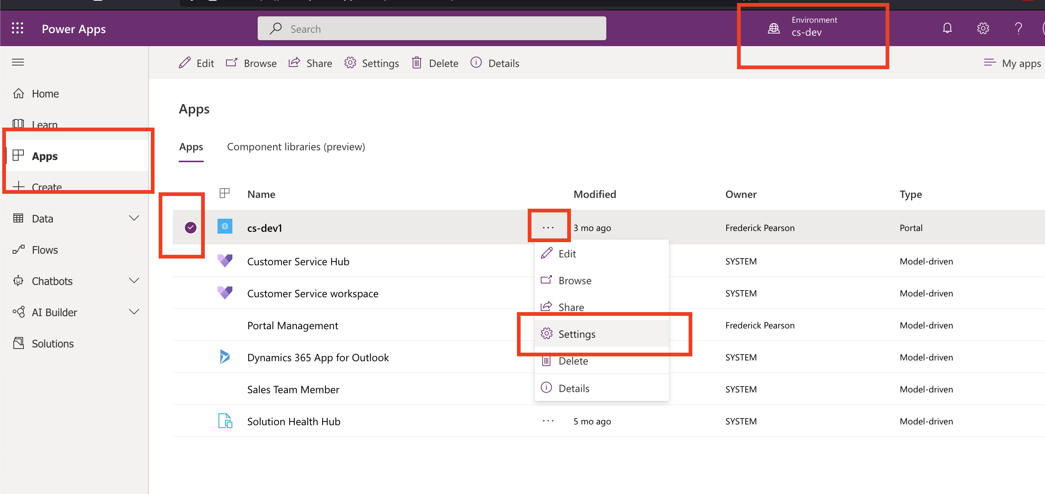

Once the modal is displayed on the right, press Administration

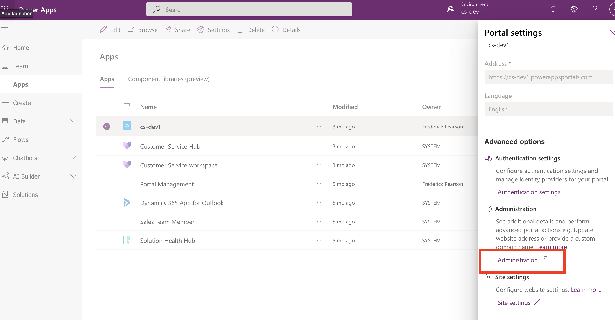

### Select the EGCS Portal Accelerator under the Website Binding dropdown (if not already selected)

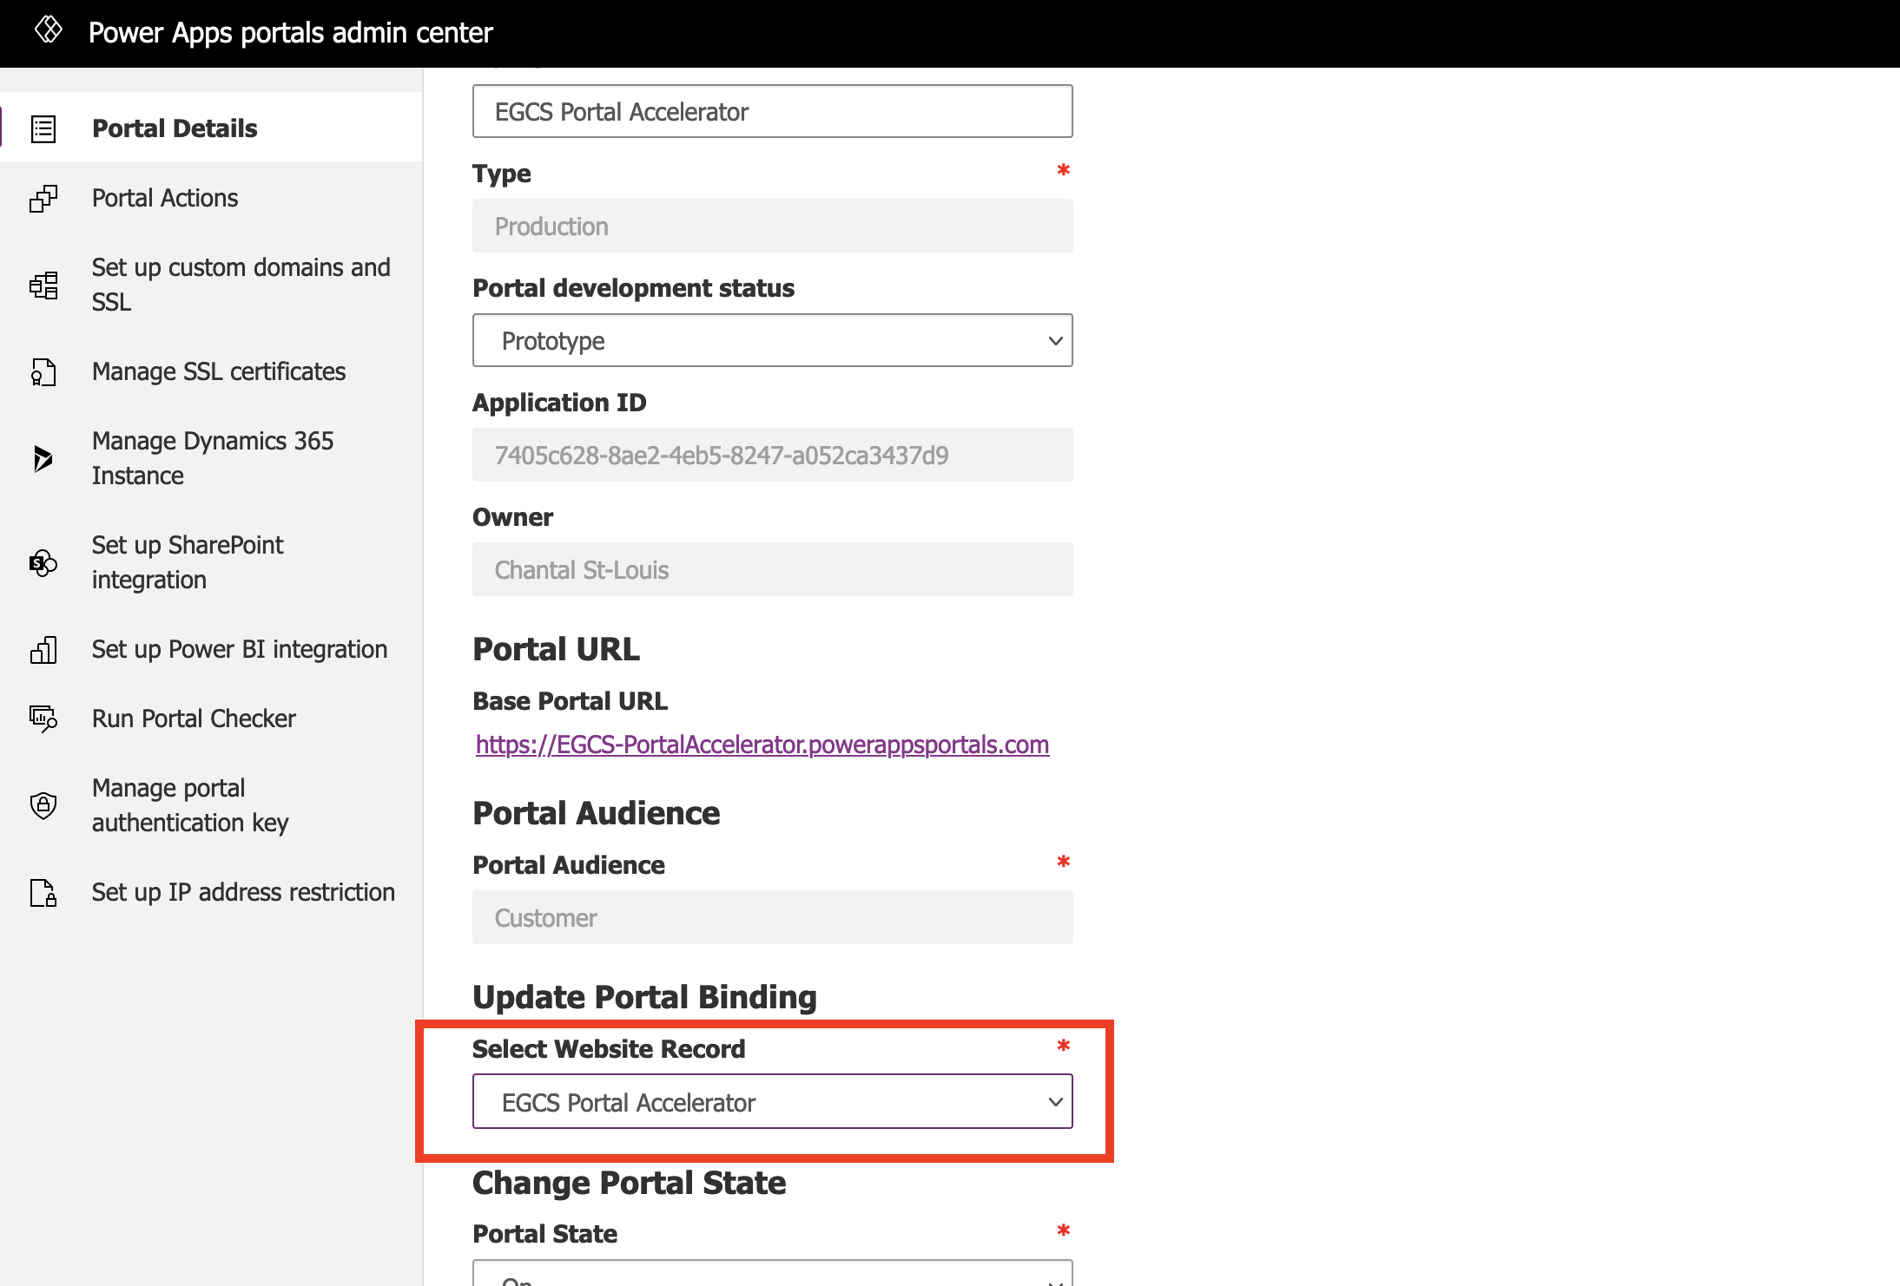

### Restart the portal and Test the Installation

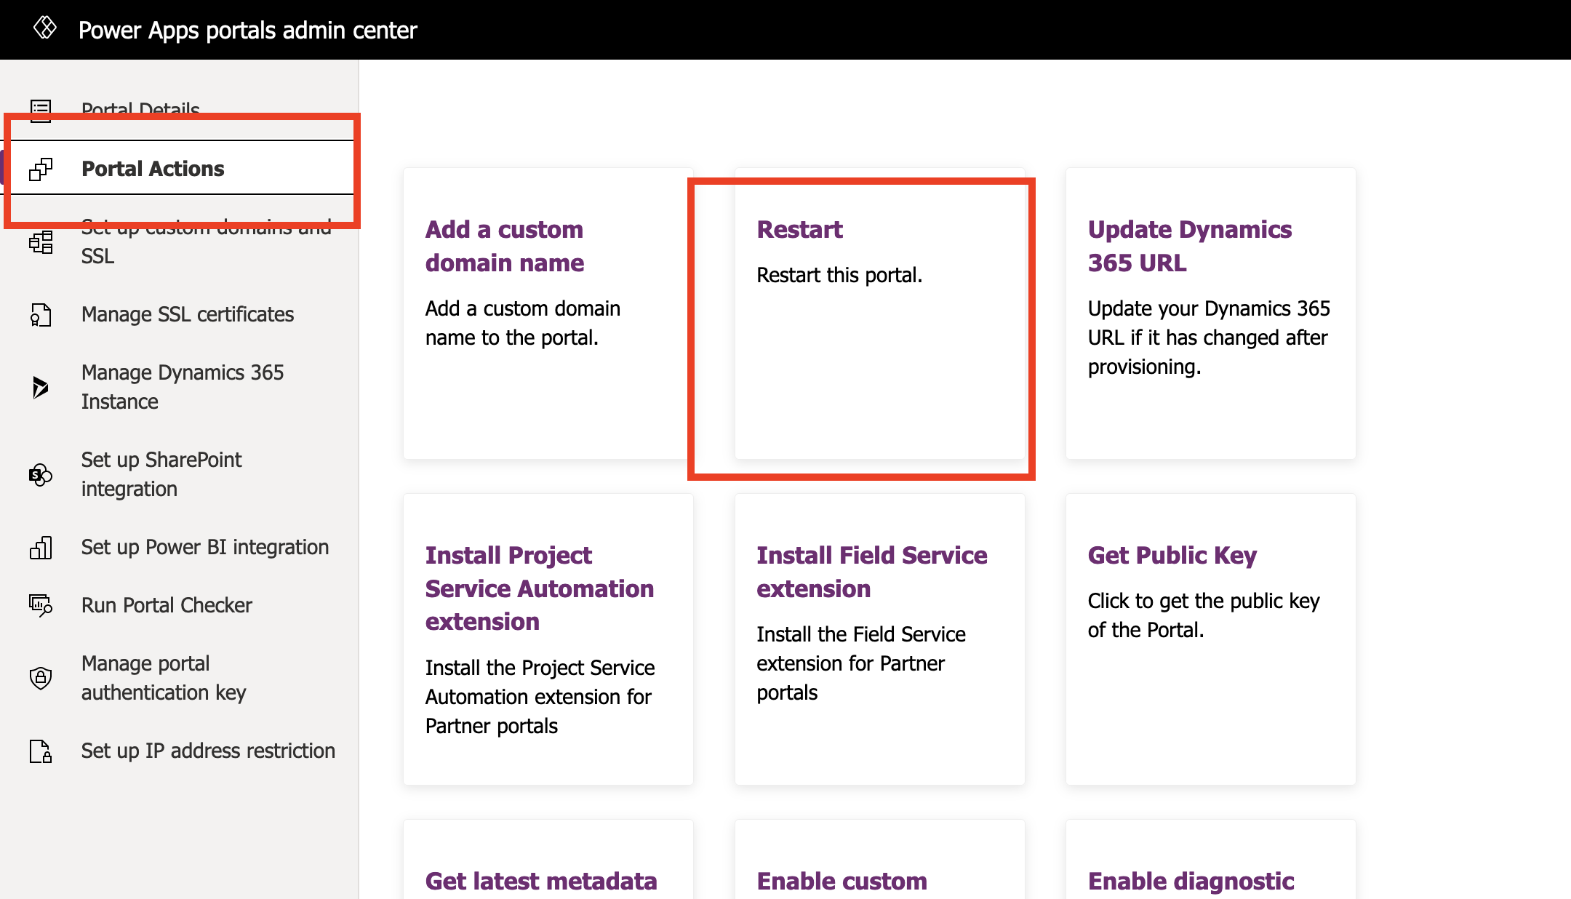

**Once restarted (this can take a few minutes), navigate to the Portal URL to validate that the following page appears. If so, the installation is successful.**

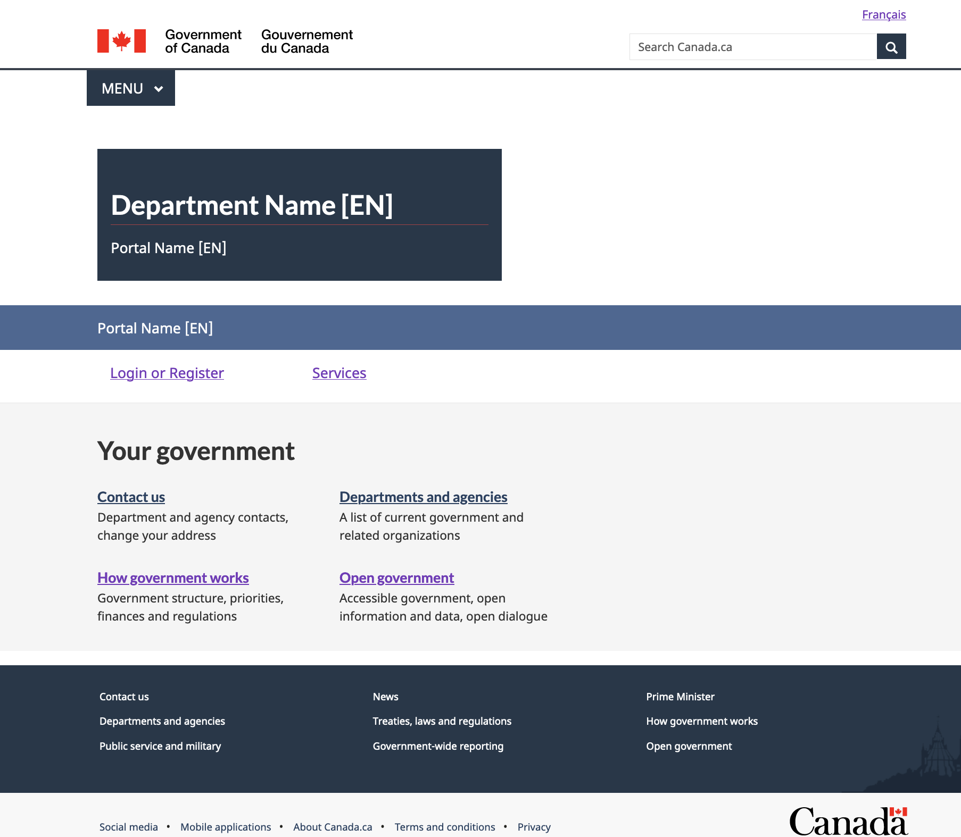

### Validate that the CRM Model Driven App has been Successfully Installed

Go to <https://make.powerapps.com> and select your environment. Verify that the following application exists:

